Arraylist is not synchronized, here multiple threads can access the same array list

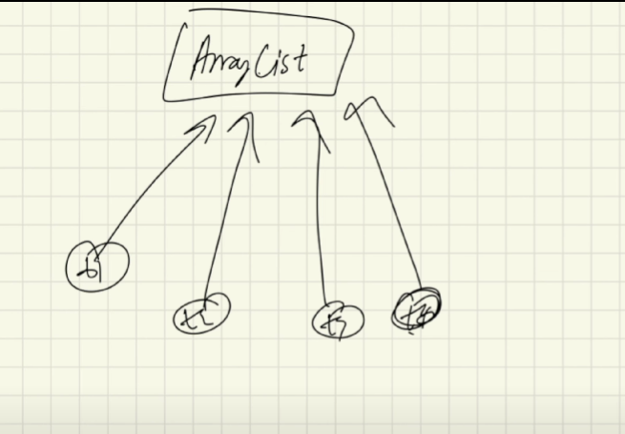

Here in Arraylist all four threads can access the same Arraylist object

Vector is synchronized, here only one thread can access the vector

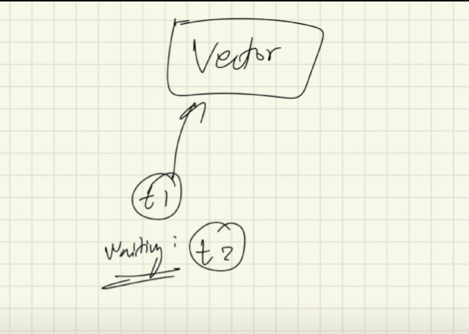

Here a thread t1 is accessing the vector object

If another thread t2 need to access the vector object it first wait until thread t1 is accessing the vector object

Which one is faster?

Arraylist is faster because here multiple threads are accessing the Arraylist, but in vector peocessor need to wait until the current thread finished it’s task

ArrayList

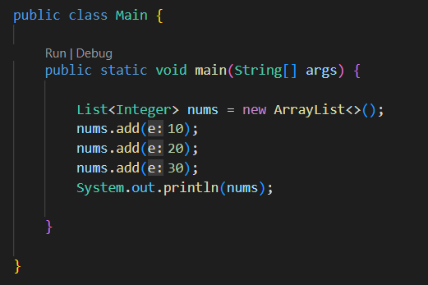

Vector

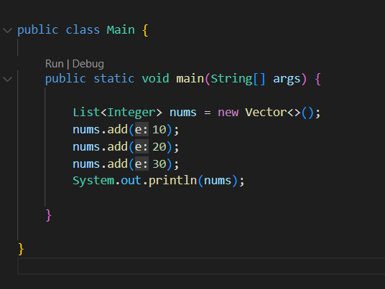

Here reference variable nums in both case is List. Here actually both ArrayList and Vector implements List interface and List interface has defined a method called add( ) which is implemented in different ways inside the class ArrayList and Vector that implements the interface List, this is the powerful aspect of interfaces in java